JAX-RS - @POST Example
POST 請求目的在更新現有資源或建立新資源。在這兩種情況下請求 URI 通常指向資源，例如http://www.example.com/api/customers（用於建立/更新一個客戶或多個客戶資料）。

客戶端在訊息內文中必須包含要更新的數據，在訊息頭中包含內容信息。內容信息（也稱為內容協定）描述內文中的數據類型以及客戶端在回應中要接受的數據類型。
- 專案結構:
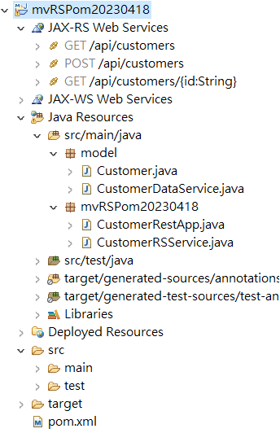
- pom.xml
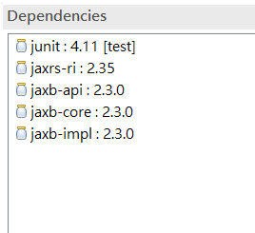
<dependency>
<groupId>org.glassfish.jersey.bundles</groupId>
<artifactId>jaxrs-ri</artifactId>
<version>2.35</version>
</dependency>
<dependency>
<groupId>javax.xml.bind</groupId>
<artifactId>jaxb-api</artifactId>
<version>2.3.0</version>
</dependency>
<dependency>
<groupId>com.sun.xml.bind</groupId>
<artifactId>jaxb-core</artifactId>
<version>2.3.0</version>
</dependency>
<dependency>
<groupId>com.sun.xml.bind</groupId>
<artifactId>jaxb-impl</artifactId>
<version>2.3.0</version>
</dependency>

建立Model:
public class Customer {
private String id;
private String name;
private String address;
private String phoneNumber;
public Customer() {
}
public Customer(String id) {
this.id = id;
}
public void setId(String id) {
this.id = id;
}
public void setName(String name) {
this.name = name;
}
public void setAddress(String address) {
this.address = address;
}

public void setPhoneNumber(String phoneNumber) {
this.phoneNumber = phoneNumber;
}
public String getId() {
return id;
}

public String getName() {
return name;
}

public String getPhoneNumber() {
return phoneNumber;
}

public String getAddress() {
return address;
}

@Override
public String toString() {
return "Customer [id=" + id + ", name=" + name + ", address=" + address + ", phoneNumber=" + phoneNumber + "]";
}
}

DAO data service程式
import java.util.ArrayList;
import java.util.List;
public class CustomerDataService {
private List<Customer> customerList = new ArrayList<>();
private static CustomerDataService ourInstance = new CustomerDataService();
public static CustomerDataService getInstance() {
return ourInstance;
}

public String addCustomer(Customer customer) {
int index=0;
String newId="1";
if(customerList.size()>0) {
index=customerList.size()-1;
newId = Integer.parseInt(customerList.get(index).getId())+1+"";
}
customer.setId(newId);
customerList.add(customer);
System.out.println("Post Customer:"+customer);
return newId;
}

public List<Customer> getCustomerList() {
return customerList;
}
public Customer getCustomerById(String id) {
for (Customer customer : customerList) {
if (customer.getId().equals(id)) {
return customer;
}
}

return null;
}
}

建立Rest App:
import javax.ws.rs.ApplicationPath;
import javax.ws.rs.core.Application;

@ApplicationPath("/api")
public class CustomerRestApp extends Application {

}

import javax.ws.rs.*;
import javax.ws.rs.core.MediaType;
import java.util.List;
import model.*;

@Path("/customers")
public class CustomerRSService {
private CustomerDataService dataService = CustomerDataService.getInstance();

@GET
@Produces(MediaType.APPLICATION_JSON)
public List<Customer> getCustomers() {
return dataService.getCustomerList();
}

@POST
@Consumes(MediaType.APPLICATION_JSON)
@Produces(MediaType.TEXT_PLAIN)
public String createCustomer(Customer newCustomer) {
return dataService.addCustomer(newCustomer);
}

@GET
@Path("/{id}")
@Produces(MediaType.APPLICATION_JSON)
public Customer getCustomer(@PathParam("id") String id) {
return dataService.getCustomerById(id);
}
}
最後使用PostMan測試:
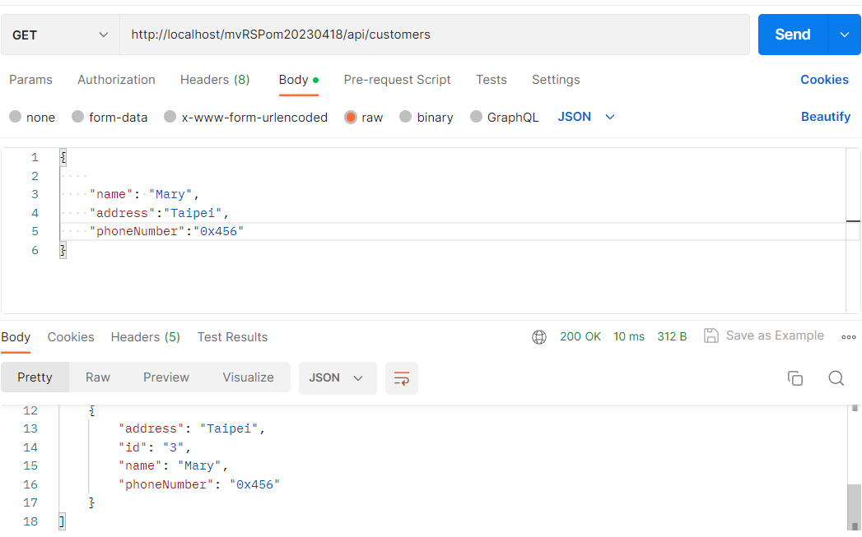
GET http://localhost/mvRSPom20230418/api/customers 取的所有資料

POST http://localhost/mvRSPom20230418/api/customers 新增JSON資料
{
"name": "Mary",
"address":"Taipei",
"phoneNumber":"0x456"
}

GET http://localhost/mvRSPom20230418/api/customers/1 取的id=1資料

